1. Write a query to display all products that have price is maximum price in the same category as below.
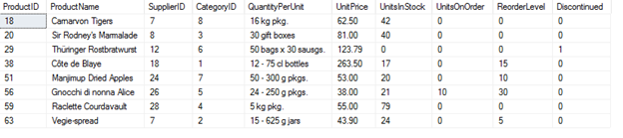
2. An order will be taxed 20% if its freight cost is larger than or equal to $100. Otherwise, an order will be taxed 10% if its freight cost is smaller than $100. Write a query to show the freight with taxes of orders placed between 1/5/1997 and 15/5/1997 as follows, by ascending order of order ID as follows.
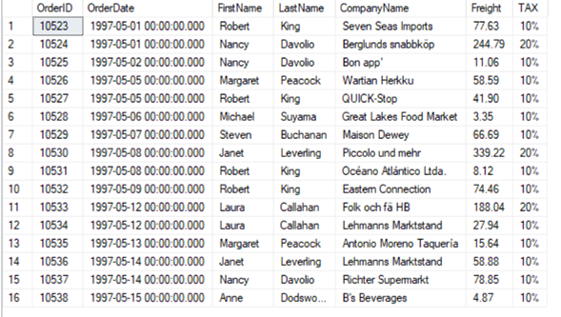
3. Write a query to display all employees that have first name starting with A, by their ID order.
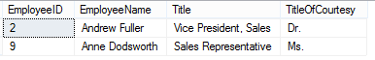
4. Write a query to display 3 youngest employees and 3 oldest employees as follows.
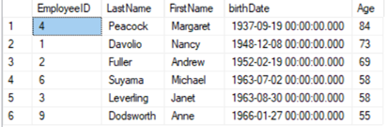
5. Write a query to display employees whose hire later is later than hire date of employee ‘Peacock Margaret’ as follows.
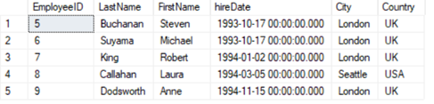
6. Write a query to display total value of each order from 1/12/1996 to 31/12/1996 as follows.
Note: Total value = sum of all (UnitPrice * Quantity).
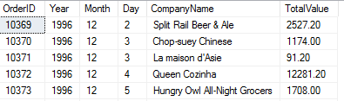
7. Write a query to display number of orders shipped by shippers as follows.
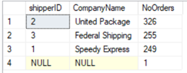
8. Write a query to display all products that have price is maximum price in the same supplier as below.
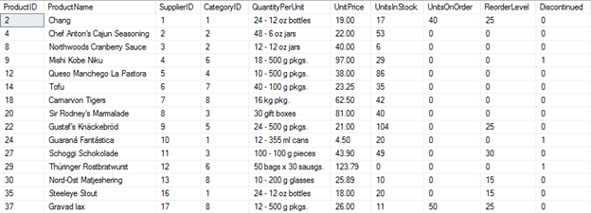
9. Write a query to display all customers that have the second character of ContactName is O, by their ID order.
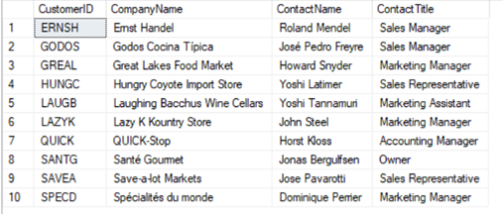
10. Write a query to display the list of young employees ranks from 4th to 8th as follows.
